JavaScript DOM Programs

1. Filter List of Names (Textbox + UL)
function findnum(a,b){
for(let i=0;i<a.length;i++){
if(a[i]==b){
return true;
}
else{
return false;
}
}
}
function filter(){
let input=document.getElementById("input").value;
let ul=document.getElementById("ul1");
let item=ul.querySelectorAll("li");
item.forEach(element => {
const text=element.textContent;
if (findnum(text,input)){
element.style.display="";
}
else{
element.style.display="none";
}
});
}
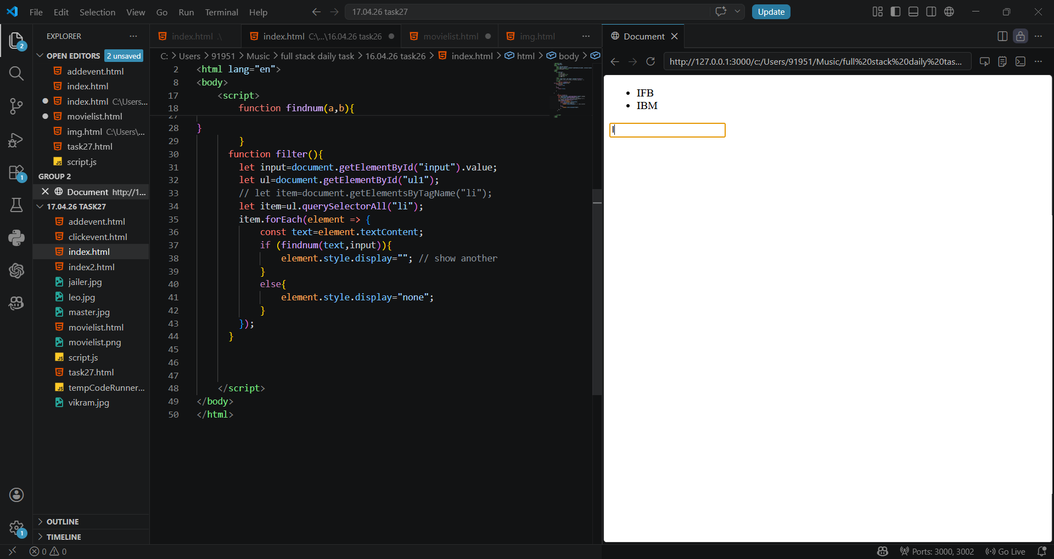
output:

2. Movie Cards Display using JavaScript
const movies = [
{name: "Leo", image: "leo.jpg"},
{name: "Jailer", image: "jailer.jpg"},
{name: "Vikram", image: "vikram.jpg"},
{name: "Master", image: "master.jpg"}
];
const container = document.getElementById("movieContainer");
movies.forEach(movie => {
let card = document.createElement("div");
card.classList.add("card");
let img = document.createElement("img");
img.src = movie.image;
let title = document.createElement("h3");
title.textContent = movie.name;
card.appendChild(img);
card.appendChild(title);
container.appendChild(card);
});
output:
